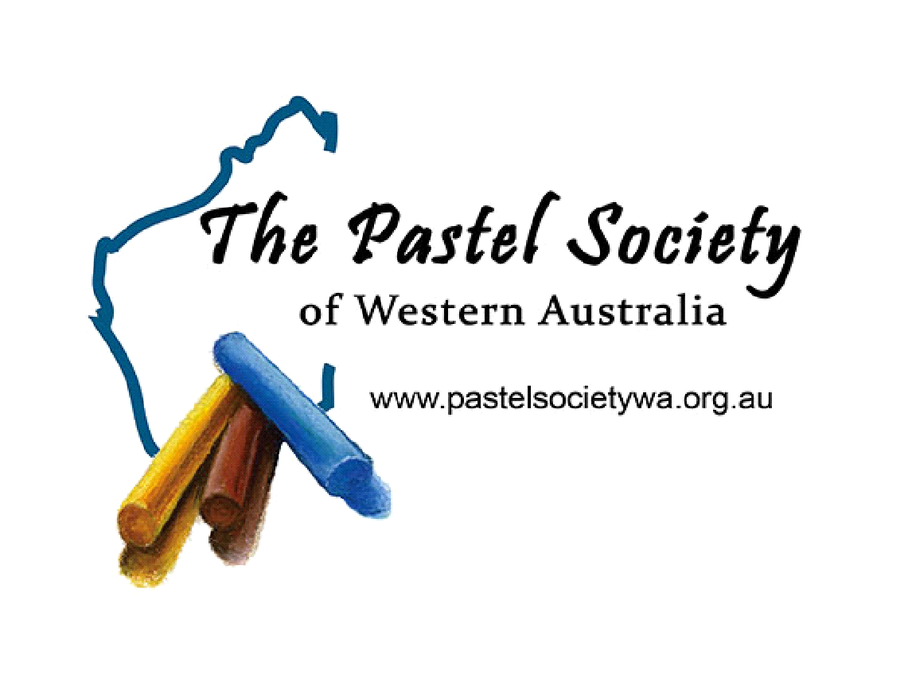
Information Sheet

What is the Pastel Society and what does it do?
The Society was formed in 1983 to cater to the needs of pastel artists of all levels of ability and to promote the medium to the public at large.
The Society host one Exhibition each year to offer artwork for sale by members and regularly invites experienced pastel artists to demonstrate their skills to members.
The Pastel Society meets every Monday 7.30pm - 9.30pm at Mildenhall, 49 Beddi Road, Duncraig, except public holidays and the Christmas school holidays. We bring our art materials and paint together, with experienced members offering help and advice. Meetings are free to attend except when there is a demonstrator. New members and visitors are always welcome.
How does Pastel differ from other art mediums?
Dry Pastels come in hard or soft varieties. Unlike other media, such as oil, watercolours or acrylics, pastels cannot be premixed by the artist to obtain a required colour prior to being applied to the art surface. To overcome this, Pastel manufacturers offer a range of pastels in many colours with each colour having 5 or more different tints or shades. As a consequence, there is a vast range of hues to tempt the pastelist.
The pigments used in pastels are exactly the same as those found in other fine art media. The difference between the media is simply the various binders which hold the pigments together. Distinct from Pastels, most other media require some preparation or mixing prior to use. The great joy of painting with Pastels is that they are ready for use immediately and there is no waiting around for the painting to dry.

Application for Membership Form (membership year runs from 1 Feb. - 31 Jan.)
Name ...........................................................................................................................................
Address .................................................................................................. Postcode .......................
Email .............................................................................................................................................
Phone ....................................................... Mob ...........................................................................
Year of Birth ............................................................ (Note: We provide your name, suburb and year of birth to City of Joondalup in order to receive a significant discount on the cost of our meeting hall hire)
It is a formality that your membership be approved by the PSWA committee, once that has been done you will be notified via email and then you can pay your membership according to the details below. You will become a member once payment has been received. We look forward to meeting you.
Membership fees current as of 1 February, 2021 (new members pay joining fee and appropriate membership fee)
Joining Fee $10 DIRECT DEBIT BANK A/C. DETAILS
Membership $50 A/c. Name: The Pastel Society of Western Australia
Country Membership $20 Bank: Commonwealth
Half Year Membership $25 BSB: 066166
(from August) A/c. No. 10265909

**(As reference please put the initial of your first name followed by your last name eg: P. Spence)**

Website: www.pastelsocietywa.org.au Email: contact@pastelsocietywa.org.au

Details below For PSWA Secretary to fill out

Approved by Committee:
Once the committee has approved the new member application secretary to tick box and sign below.

Secretary of The Pastel Society of Western Australia

